1. The *ten-bit* Gray code for **35310** is **0111010001**. Explain briefly but precisely why it cannot be true that **0111010100** is the ten-bit Gray code for 35410 **also** calculate gray code for (354)10.

**2+1**

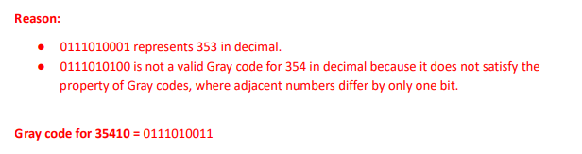

1. Using 10's complement. subtract 72532 - 3250. **3**

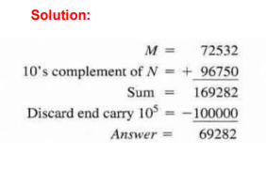

1. Given the two binary numbers **X = 1010100** and **Y = 1000011** perform the subtraction

X - Y and Y - X by using 2's complements **2+2**

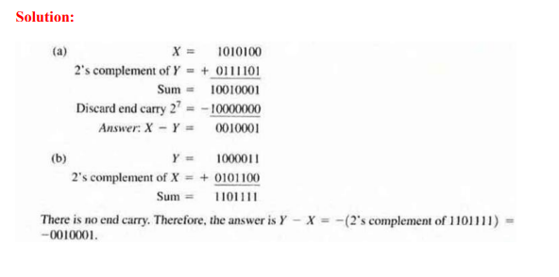

1. Simplify the following Boolean Functions to minimum possible number of literals. **5+5**
2. AC’D’ + A’C + ABC + AB’C + A’C’D’

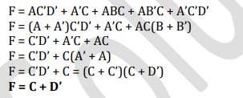

b) (𝐴′ + 𝐵)’ (𝐴′ + 𝐶′)’ (𝐴𝐵′𝐶)’

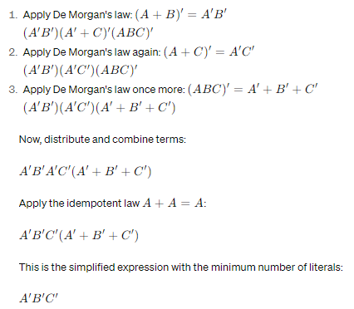

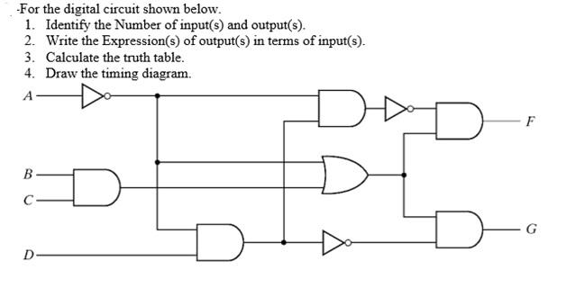

**2+2+3+3**

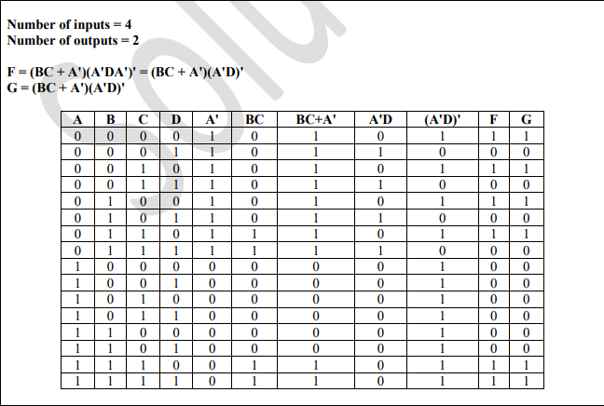

1. Use 2’s complement to find A + B in the following cases and verify that your answer is correct. All the numbers given are signed numbers. **5+5**

a) A = (-57)10 and B = (35)8

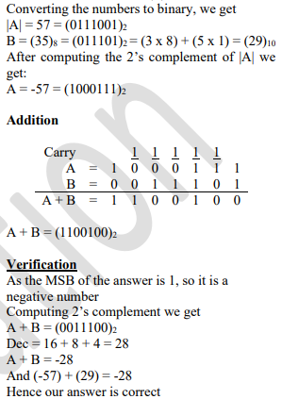

b) A = (41)10 and B = (33)16

